Kendriya Vidyalaya Tamenglong

Summative Assessment 1

Subject: E V S Name : ...................... Time:2 hrs

Class : v Roll :

|  |  |  |  |  |
| --- | --- | --- | --- | --- |
| COMPETENCY | OBSERVATION | IDENTIFICATION | DISOVERY OF FACTS | TOTAL |
| VALUE POINTS |  |  |  |  |
| GRADE |  |  |  |  |

Sign of invigilator sign of evaluator.

**OBSERVATION AND REPORTING**

1.Observe the picture and answer the following questions

1. What is the name of the animal seen in the picture?



Ans:-____________

1. How many years does the animal live?

Ans:-__________

2. What do you observe in the glass jar?Ans: __________________



3. What do you observe in the picture given below?Ans:______________



4. What is this picture?Ans:_____________________



5. How do people get water from here?Ans:_________________

6. What is the man doing in the picture given?Ans:-_______________

7. What is given to the patient in the picture?

Ans:-______________ 

b. Why is it given to the patient?

Ans:-______________

**2. Answer the following questions.**1. Look at the water bill and answer the questions.

1. From which office has this bill come?

Ans:-_______________________

1. In whose name is the bill?

Ans:- _______________________

1. How much money do they have to pay for each month?

Ans:-________________________

1. Do you pay water bill and how much? Ans:-_______________________

2. What do you observe in the given picture and answer the following.

1. What is the name of the sea?

Ans:- __________________ 

1. Why is the man floating in the water?

Ans:-

1. Observe the following picture and answer the following pictures
2. What is the name of the plant given in the picture?

Ans:-____________________ 

1. Where do you find this plant in India?

Ans:-___________________

1. What is the scientific name of this plant?

Ans:- ___________________

1. What does this plant eat?

Ans:-____________________

1. . Observe the picture and write for how many hours a day that animal sleeps

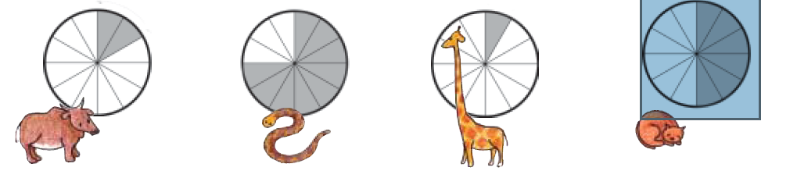

Cow__________ Python__________ Giraffe__________ Cat__________

***IDENTIFICATION AND CLASSIFICATION***

**3. Look carefully at the map of Golconda and answer the following questions.**



1. How many ‘darwazas’ are there in this map?

Ans:-...........................................................................................................................................................

1. In which direction ‘Katora Hauz’ is located?

Ans:-...........................................................................................................................................................

1. How many stores for gunpowder are there in this fort ?

Ans:-............................................................................................................................................................

1. What arrangements for water can you see inside the fort?

Ans:-...........................................................................................................................................................

1. In which direction moti darwaza is located?

Ans:- ...........................................................................................................................................................

**Answer the following questions:-**

1. What are endangered animal?

Ans:-............................................................................................................................................................

1. Who went on a yatra from Ahmadabad to Dandi and why?

Ans:-.............................................................................................................................................................

1. What is digestion?

Ans:.............................................................................................................................................................

.....................................

1. What are the different ways of preserving food?

Ans. ............................................................................................................................................................

...................................................................

1. Who are poachers?

Ans:- ...........................................................................................................................................................

.....................................................................................................................................................................

**Answer the following questions:-**

1. What are the food items that can be made using raw and ripe mangoes?

Ans: ...............................................................................................................................

1. What are the conditions a seed needs to germinate?

Ans:- ...................................................................................................................................

1. What is Kalbelia dance?

Ans:- ......................................................................................................................................

1. How many sense organs are there and what are they?

Ans:- .........................................................................................................................................

1. What kinds of tools are needed for climbing mountains?

Ans:- ...............................................................................................................................................

Classify the following substances which will float and which will sink?

1. Leaf b. Keys c. Plastic ball d. Coin e. Oil f. Bottle with water

g. Paper h. Soap i. Bottle cap j. Soap with plastic tray

|  |  |
| --- | --- |
| Float | Sink |
|  |  |
|  |  |
|  |  |
|  |  |
|  |  |

**DISCOVERY OF FACTS**

Answer the following questions

1. Who is the first Indian women to reach the peak of mount Everest?

Ans:-______________________________________________

1. Why are bastions made in the fort wall?

Ans:- ...................................................................................................................................................

......................................................................................

1. What are the colours in the National Flag?

Ans:- ...................................................................................................................................................

1. Why should we chew food properly?

Ans :- ............................................................................................................................................................

............................................................

1. Why lizards are not seen in winter?

Ans :- ........................................................................................................................................................

...................................................................................

II. Answer the following questions.

1. Draw the diagram of globe?
2. Who is Sunita Williams? What world record has she made?

Ans:- ........................................................................................................................................................

.................................................................................................................................................................

1. Who has discovered Malaria causing mosquitos and where?

Ans:-__________________________________________________

1. Differentiate the following substances which will dissolve and which do not dissolve?
   1. Salt b. Soil c. Chalk Powder d. Sugar

Ans :- ..........................................................................................................................................................

..................................................................................................................................................................

1. How do snakes help farmers?

Ans :- ...........................................................................................................................................................

...................................................................................................................................................

Look at Arthi’s Blood report and answer the following questions:-

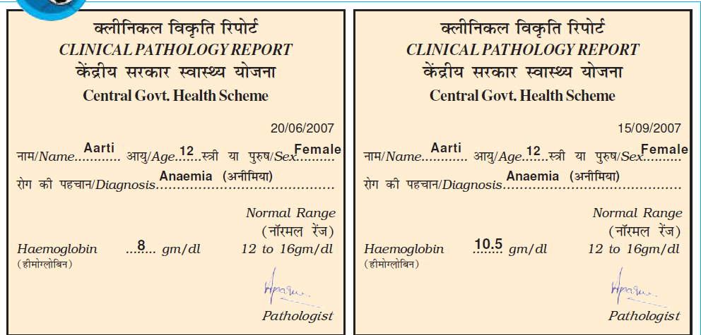

1. Look at Aarti’s blood report and find out the minimum

Required hemoglobin?

Ans:-..........................................................................................................................................................

1. How much did Aarti's haemoglobin go up?

Ans:-............................................*............................................................................................................*

1. How long did it take for the Haemog*lobin* to increase?

Ans:-..........................................................................................................................................................

1. What was the diagnosis?

Ans:-...................................................................................................................................................

1. How old is Arti ?

Ans:- ................................................................................................................................................

Kendriya Vidyalaya Tamenglong

Summative Assessment 1

Subject: E V S Name : ...................... Time:2 hrs

Class : v Roll :

|  |  |  |  |  |
| --- | --- | --- | --- | --- |
| COMPETENCY | OBSERVATION | IDENTIFICATION | DISOVERY OF FACTS | TOTAL |
| VALUE POINTS |  |  |  |  |
| GRADE |  |  |  |  |

Sign of invigilator sign of evaluator